Lab Answer Key: Module 2: Upgrading and updating Windows 11

Lab 2: Upgrading and updating Windows 11

**Scenario**

You are involved with a project within A. Datum Corporation to deploy Windows 11 on the computers of all users. You are performing a trial Windows 11 deployment by performing a test upgrade of a small group of devices, starting with a single Windows 10-based computer. You will also test the feasibility of migrating user settings for those users who will receive new hardware. I

**Objectives**

After completing this lab, you will have:

* Determined which users' computers can be upgraded.
* Migrated user settings between two computers.
* Managed Windows 11 updates

Exercise 1: Verifying feasibility of in-place upgrade to Windows 11

**Scenario**

You want to start your deployment of Windows 11 by determining whether you can upgrade a Windows 10 computer.

The main tasks for this exercise are as follows:

1. Verify minimum hardware requirements.

Task 1: Verify that the computer meets the minimum requirements

1. From the Home Tab of the LMS, switch to the [**LON-CL3**](urn:gd:lg:a:select-vm) Virtual Machine.
2. Click [**CTRL+ALT+DEL**](urn:gd:lg:a:send-vm-key-combo) button on the Home tab.
3. Sign in as [**ADATUM\AdatumAdmin**](urn:gd:lg:a:send-vm-keys) with the password [**Pa55w.rd**](urn:gd:lg:a:send-vm-keys).

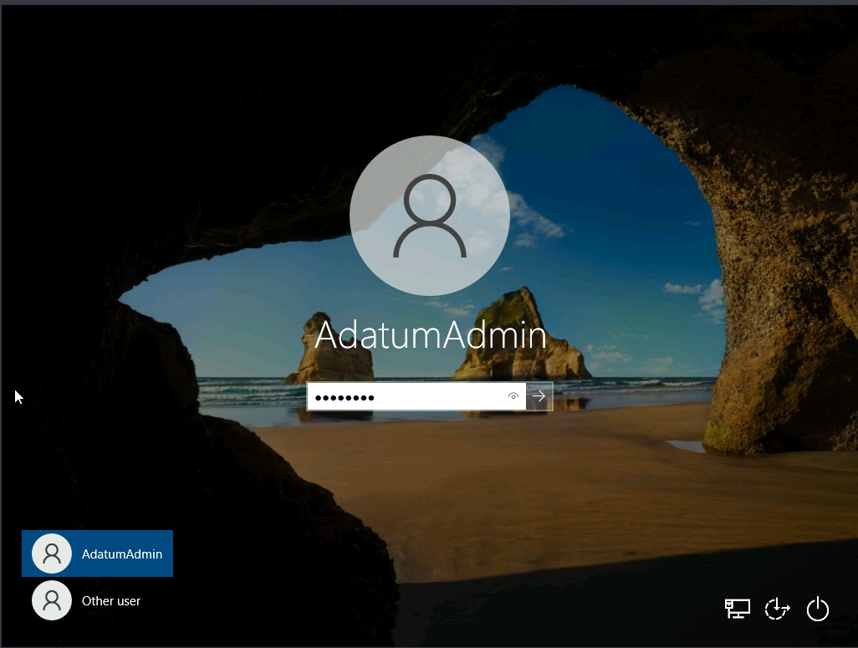

1. On the taskbar, click **File Explorer**. Right-click **This PC** , and then click **Properties**.

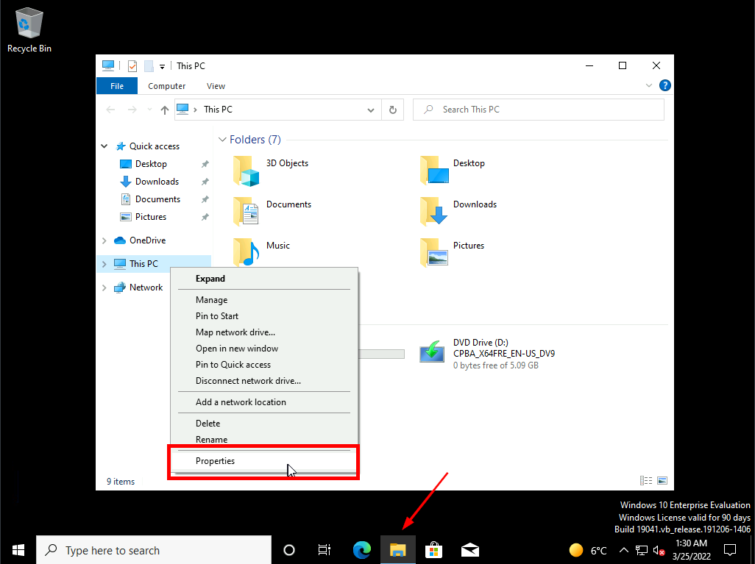

1. Record the settings for **Processor** and **Installed RAM**.

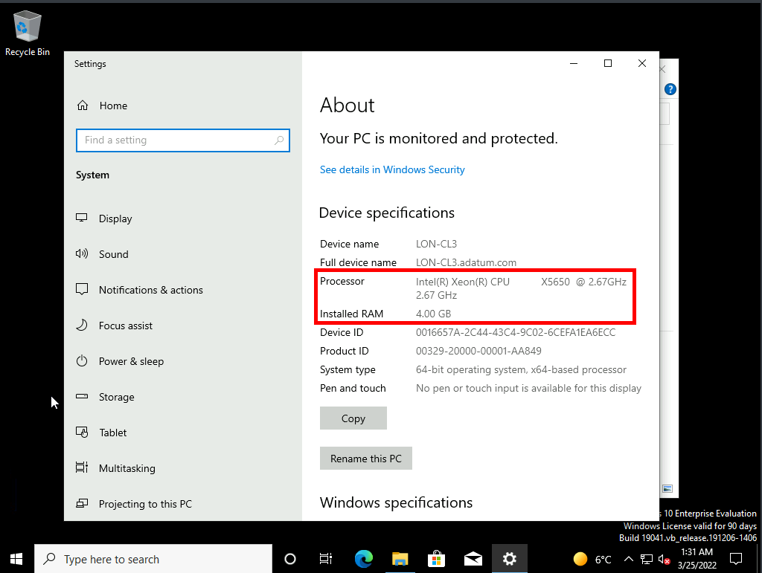

1. Close Settings.
2. Right-click the desktop, and then click **Display settings**.

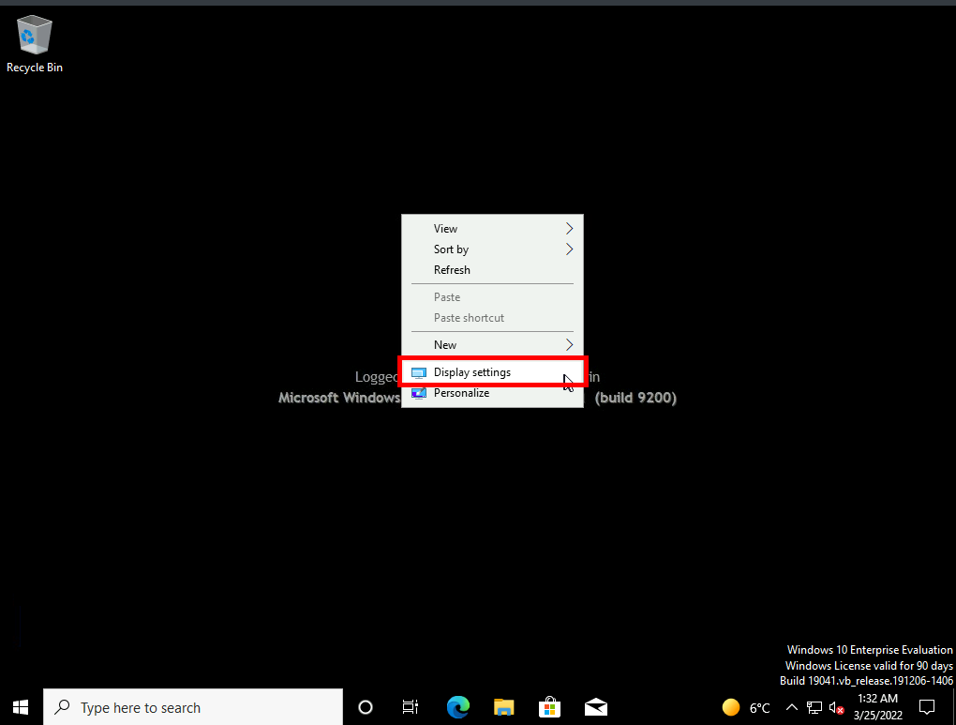

1. Record the screen resolution.

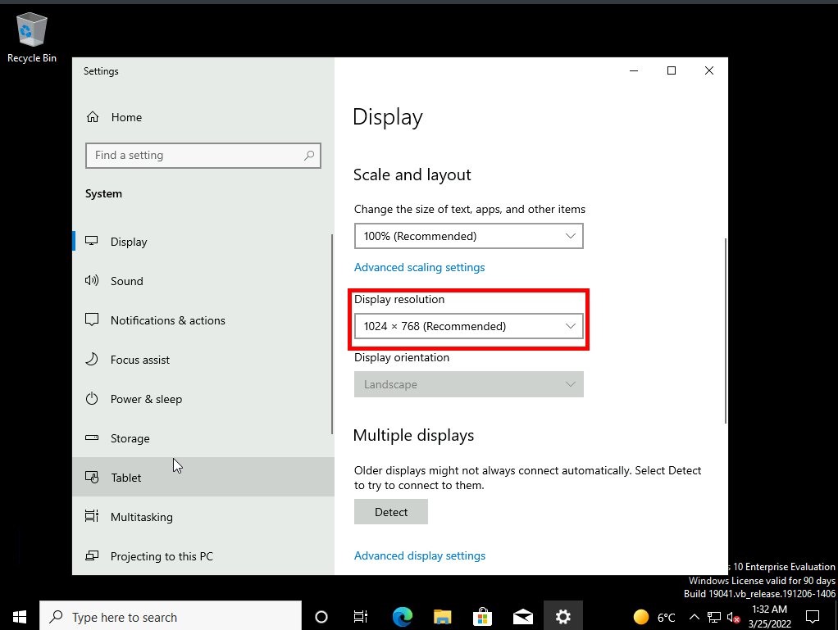

1. Switch to File Explorer.
2. Click **This PC**.

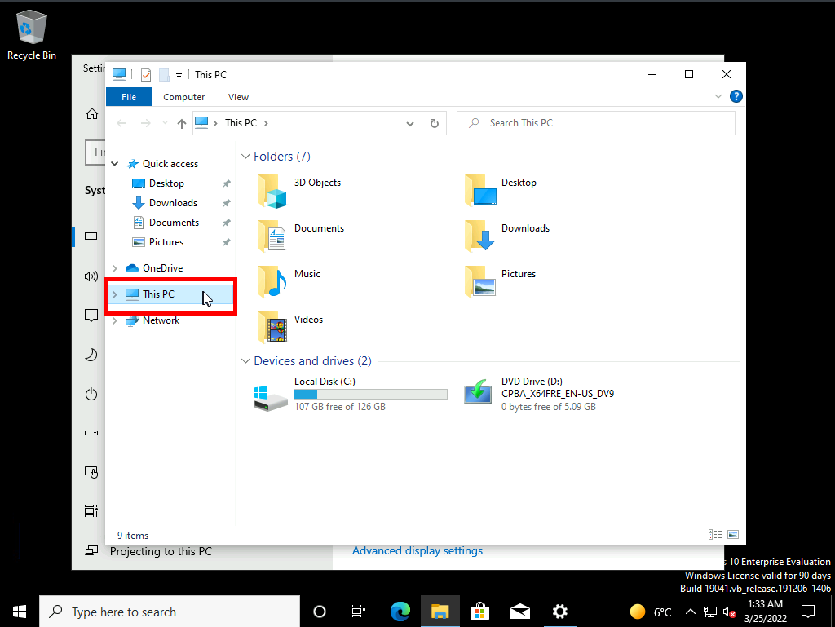

1. Note the available disk space for drive C.

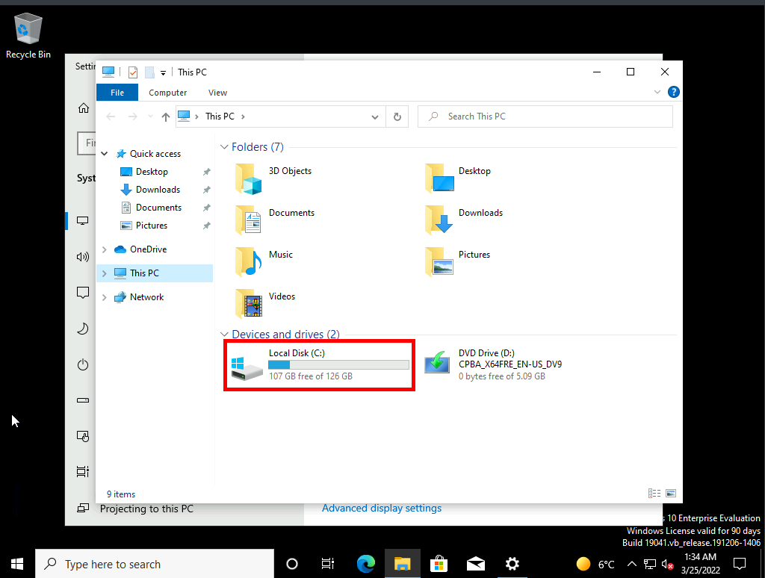

1. Do the noted values match the minimum requirements?
2. Which setting, if any, doesn't match the minimum requirements?

**Result**: After completing this exercise, you will have determined whether you can upgrade your computer to Windows 11.

Exercise 2: Migrating User Settings

**Scenario:**

You can use the in-place upgrade for most of your computers, but you will replace some of the older computers with more modern hardware that includes touch screens. You need to verify that you can migrate users' settings from their old Windows 10-based computers to the new Windows 11-based computer. You decide to test migration of user state using the USMT.

The main tasks for this exercise are as follows:

1. Prepare the source computer.
2. Perform the migration.
3. Verify the migration

Task 0: Creating the migration folder on DC1

1. Switch to [**LON-DC1**](urn:gd:lg:a:select-vm)
2. Sign in as [**ADATUM\AdatumAdmin**](urn:gd:lg:a:send-vm-keys) with the password [**Pa55w.rd**](urn:gd:lg:a:send-vm-keys).
3. Open the **file explorer** and navigate to the **C drive**.

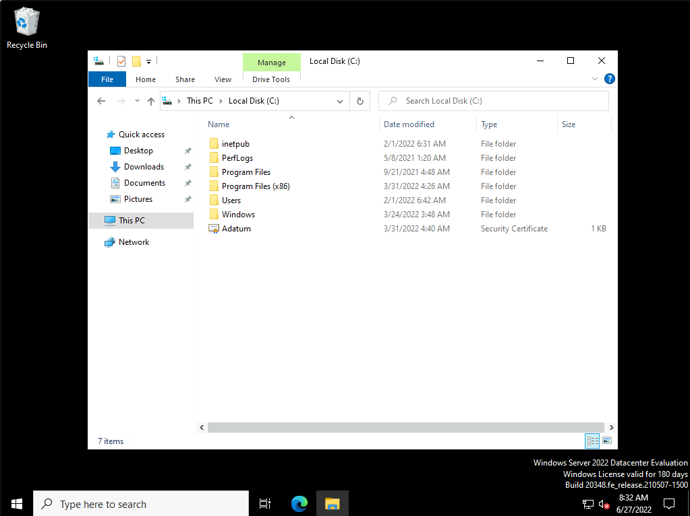

1. Right click and create a new folder named **[MigrationStore](urn:gd:lg:a:send-vm-keys" \o "Paste text into VM)**.

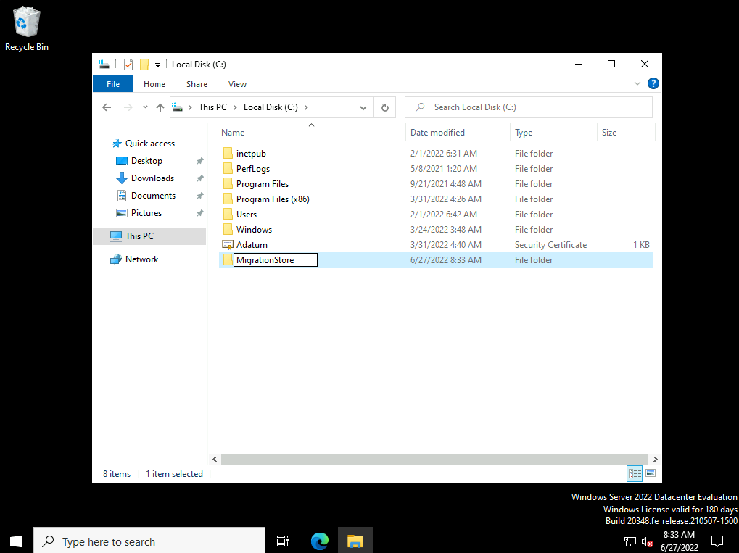

1. Right click on the newly created folder and select **Give access to > Specific people**.

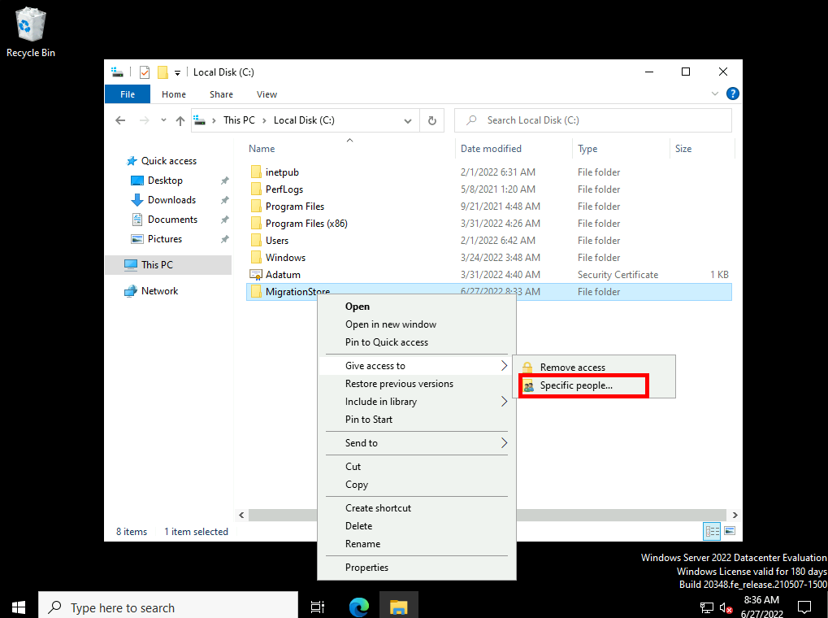

1. In the text box type everyone and click **Add**.

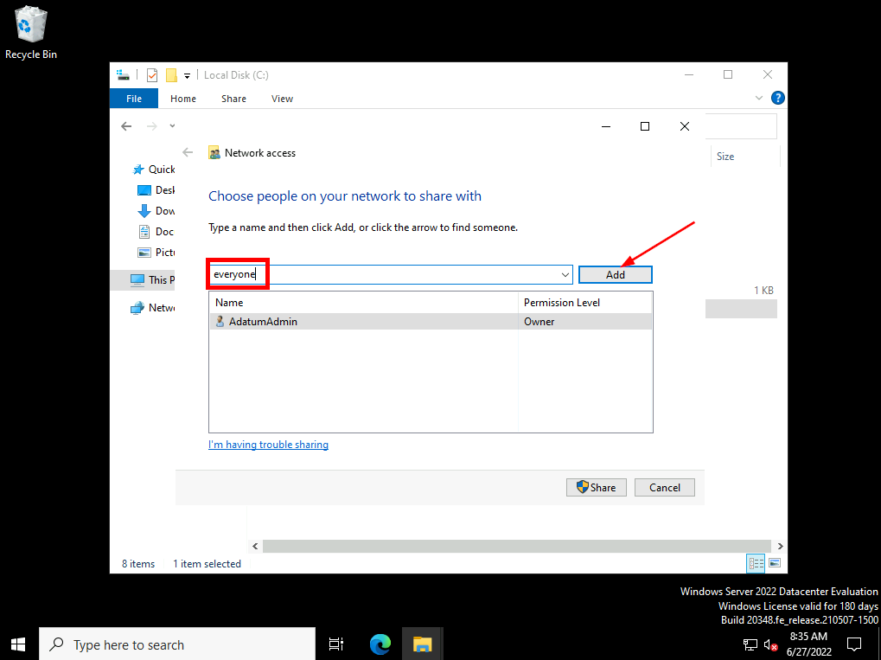

1. Finally click **Share**.

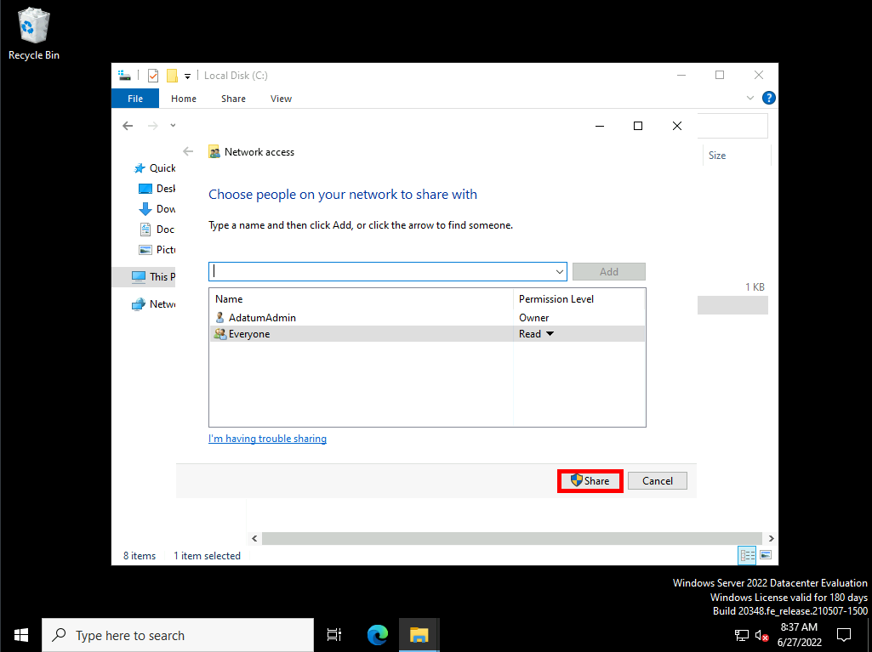

Task 1: Prepare the source computer

1. Ensure the [**LON-CL3**](urn:gd:lg:a:select-vm) Virtual Machine is selected from the Home tab of lab environment and click the [**CTRL+ALT+DEL**](urn:gd:lg:a:send-vm-key-combo) button to activate the login screen. Sign in as **[Adatum\AdatumAdmin](urn:gd:lg:a:send-vm-keys" \o "Paste text into VM)** with the password [**Pa55w.rd**](urn:gd:lg:a:send-vm-keys).
2. Right-click the desktop, hover over the **New** menu item, and then click **Text Document**. Type **[Demofile](urn:gd:lg:a:send-vm-keys" \o "Paste text into VM)** and press Enter.

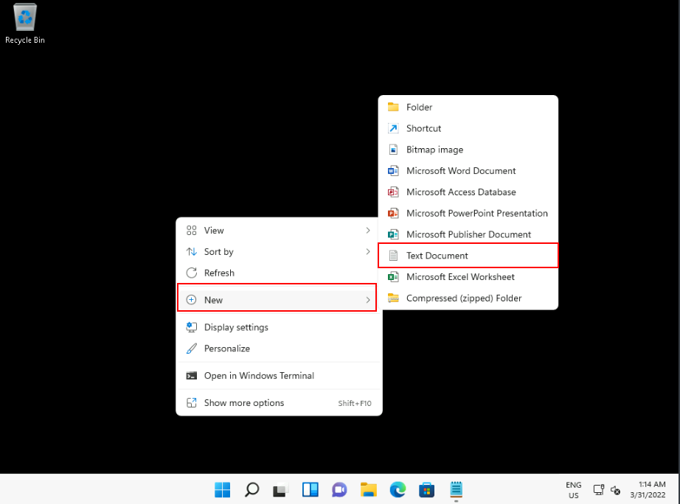

1. Double-click **Demofile.txt** and type some random text. Click **File**, and then click the **Save** button. Then exit Notepad.

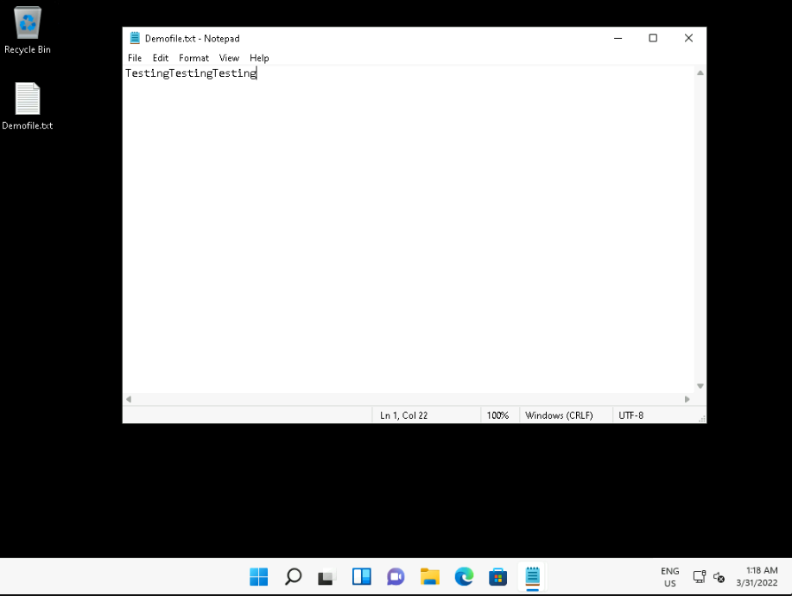

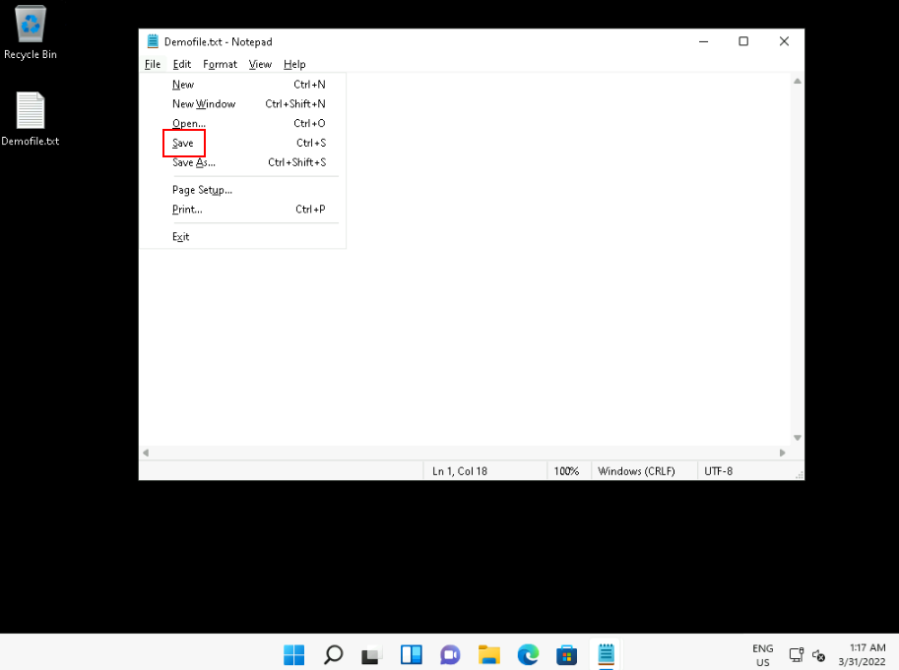

1. Click **Start** , type **[cmd](urn:gd:lg:a:send-vm-keys" \o "Paste text into VM)** , and then click **Run as administrator**.

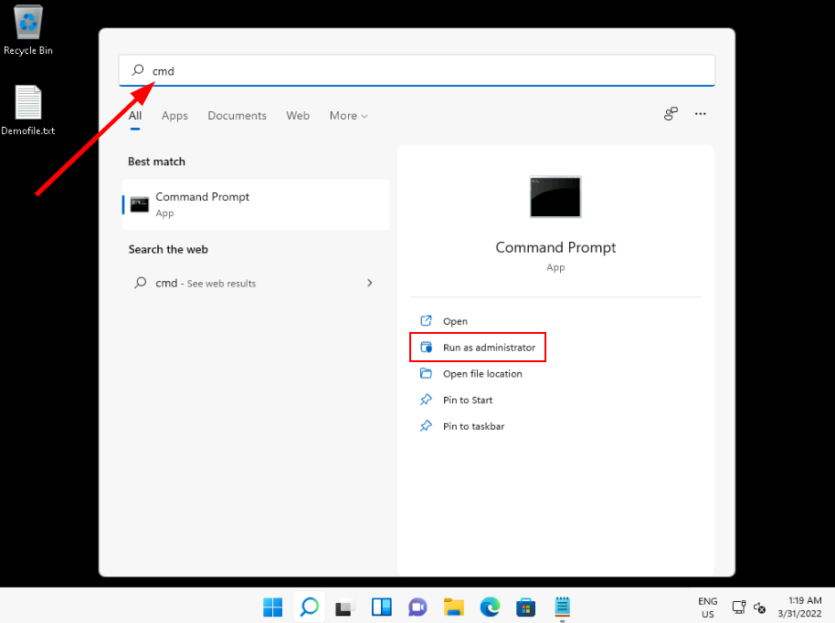

1. At the **User Account Control** prompt, click **Yes**.

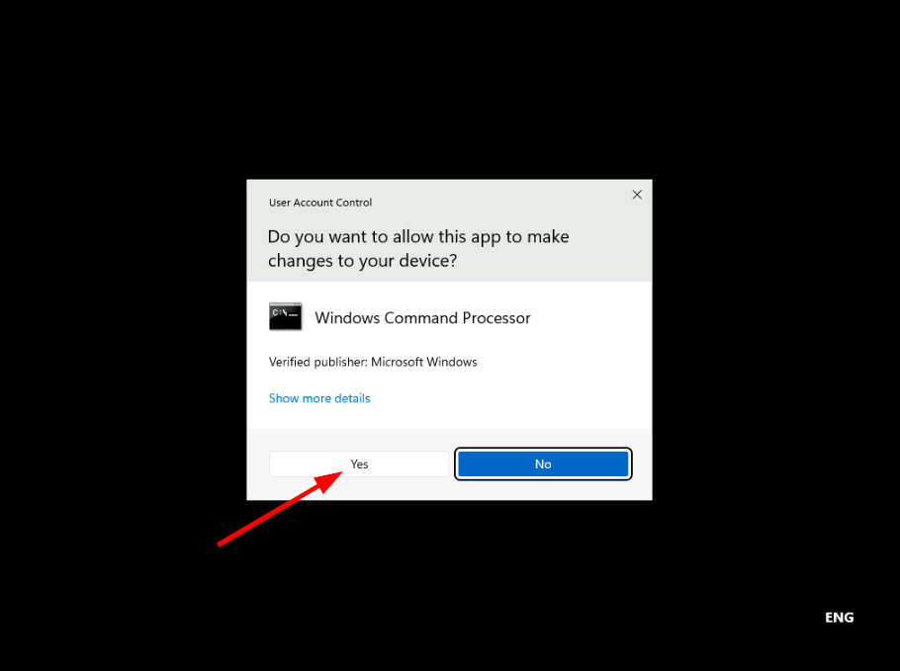

1. At the command prompt, type the following command, and then press Enter:
2. Net Use F: \\LON-DC1\USMT\amd64

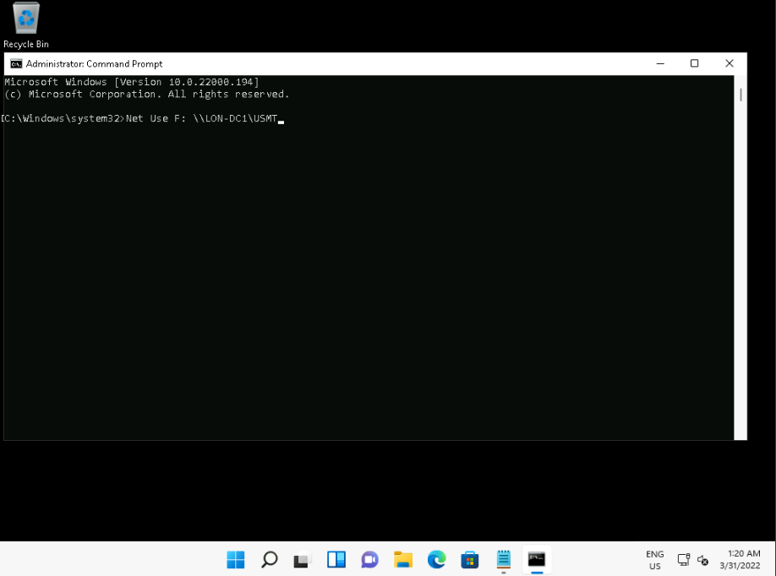

1. At the command prompt, type **F:** , and then press Enter.

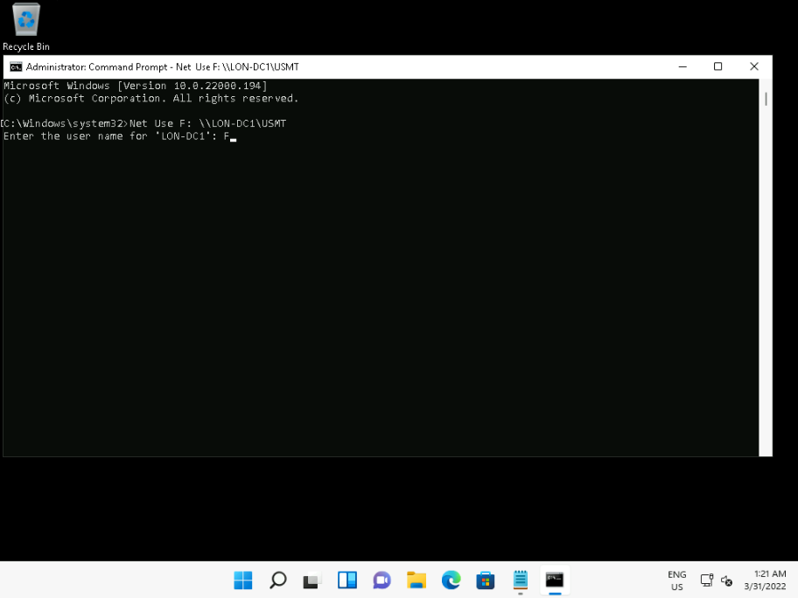

1. At the command prompt, type the following, and then press Enter:
2. Scanstate \\LON-DC1\MigrationStore\LON-CL3\ /i:migapp.xml /i:miguser.xml /o

**Note:** This could take up to two hours to complete.

Task 2: Perform the migration

1. Switch to the [**LON-CL1**](urn:gd:lg:a:select-vm) Virtual Machine using dropdown menu in the Home tab of the lab environment.

**Note:** You must have completed the preceding exercise to continue past this point.

1. Sign in as **[Adatum\AdatumAdmin](urn:gd:lg:a:send-vm-keys" \o "Paste text into VM)** with the password [**Pa55w.rd**](urn:gd:lg:a:send-vm-keys).
2. Notice that there is no Demofile.txt on the desktop.
3. Click **Start** , type **[cmd](urn:gd:lg:a:send-vm-keys" \o "Paste text into VM)** , and then press Enter.
4. At the command prompt, type the following command, and then press Enter:
5. Net Use F: \\LON-DC1\USMT\amd64
6. At the command prompt, type **F:** , and then press Enter.
7. At the command prompt, type the following, and then press Enter:
8. Loadstate \\LON-DC1\MigrationStore\Lon-CL3\ /i:migapp.xml /i:miguser.xml /lac:Pa55w.rd /lae

**Note:** This could take up to two hours to complete.

1. Type **exit** to close the command prompt.

Task 3: Verify the migration

Notice that the demofile.txt is now on the desktop and the Internet Explorer and Windows Media Player icons are visible on the taskbar.

**Result**: After completing this exercise, you will have migrated user data and settings to a Windows 11-based computer.

Exercise 3: Manage Windows 11 updates

**Scenario:** It is important to keep your users' Windows 11 devices up to date. In your test lab, you configure your computers' Windows Update settings manually. However, because there are many Windows 11-based computers in your organization, you decide to implement GPOs to configure Windows Update settings.

The main tasks for this exercise are as follows:

1. Configure update settings for a single device.
2. Review applied updates.
3. Configure update settings by using GPOs.
4. Verify that the device's update settings are managed centrally.

Task 1: Configure update settings for a single device

1. Switch to [**LON-CL1**](urn:gd:lg:a:select-vm).
2. Right-click **Start**, and then select **Windows Terminal (Admin)**.
3. At the UAC prompt, click **Yes**.
4. On the **Administrator: Windows PowerShell** tab, type the following command, and then press Enter:
5. Set-Service wuauserv -Startuptype Manual

**Note:** In the lab setup, the Windows Update service is disabled. The above command is not necessary to run on a normal Windows 11 device.

1. Click **Start**, and then click the **Settings** icon.
2. In **Settings**, click **Windows Update**.
3. On the **Windows Update** tab, click **Advanced options**.
4. On the **Advanced options** page, enable **Receive updates for other Microsoft products**.
5. Click **Delivery Optimization**.
6. On the **Delivery Optimization** page, enable the **Allow downloads from other PCs** option.
7. Select **Devices on the Internet and my local network**, and then click **Windows Update** in the navigation pane.
8. In the navigation pane, click **Windows Insider Program**. You can opt into the Insider Program from here.
9. In the navigation pane, click **Windows Update**.

Task 2: Review applied updates

1. On the **Windows Update** page, click **Update history**.
2. Review any updates listed, and then click **Uninstall updates**.
3. Review any updates listed in **Installed Updates**. Close **Installed Updates**.
4. In the navigation pane, click **Windows Update**.

Task 3: Configure update settings by using GPOs

1. In the Windows PowerShell prompt, type **[gpedit.msc](urn:gd:lg:a:send-vm-keys" \o "Paste text into VM)**, and then press Enter.
2. In **Local Group Policy Editor**, navigate to **Computer Configuration/Administrative Templates/Windows Components/Windows Update/Manage end user experience**.
3. In the details pane, double-click **Specify active hours range for auto-restarts**.
4. Click **Enabled** and then select **8** in the **Max range** list. Click **OK**.
5. In the details pane, double-click **Configure Automatic Updates**.
6. Click **Enabled** and then click **OK**.
7. In the details pane, double-click **Remove access to "Pause updates" feature**.
8. Click **Enabled** and then click **OK**.
9. In **Local Group Policy Editor**, navigate to **Computer Configuration/Administrative Templates/Windows Components/Windows Update/Manage updates offered from Windows Update**.
10. In the details pane, double-click **Manage preview builds**.
11. Select **Enabled** and review the available options in the drop down list. Then select **Disabled** and click **OK**.
12. In the right pane, double-click **Select when Preview Builds and Feature Updates are received**.
13. In the details pane, double-click **Select when Preview Builds and Feature Updates are received**.
14. Select **Enabled** and enter **60** in the **How many days after a Feature Update is released ...** text box. Click **OK**.
15. In the details pane, double-click **Select when Quality Updates are received**.
16. Select **Enabled** and enter **15** in the **After a quality update is released ...** text box. Click **OK**.

Task 4: Verify that the device's update settings are managed centrally

1. In the Windows PowerShell prompt, type **[gpupdate /force](urn:gd:lg:a:send-vm-keys" \o "Paste text into VM)**, and then press **Enter**.
2. Close the Local Group Policy Editor.
3. Close and reopen **Settings**.
4. In Settings, in the navigation pane, click **Windows Update**. Notice that the **Pause updates** option is unavailable.
5. Click **Advanced options** and then click **Active hours**.
6. Click **Manually** and notice the maximum allowable in an eight hour period.
7. Close all open apps and windows.

**Result**: After completing this exercise, you will have reviewed and tested update settings for Windows 11.

**Congratulations!** You have now completed this lab. To continue to the next lab click End Lab in the Tools Menu . If you wish to contiue with this lab at a later date ensure you save the lab environment rather than ending it.